

**MECHATRONICS SYSTEM INTEGRATION (MCTA 3203)**

**SECTION 2, SEMESTER 1, 2024/2025**

**ACTIVITY REPORT**

**Week 2: Digital Logic Design**

**Interfacing a 7-segment display with Arduino. Numbering sequence from 0 to 9.**

| **No** | **Name (Group 6)** | **Matric No.** |
| --- | --- | --- |
| **1** | **MUHAMMAD BASIL BIN ABDUL HAKIM** | **2215315** |
| **2** | **MUHAMMAD SYAFIQ BIN NOR AZMAN** | **2213187** |
| **3** | **MUHAMMAD HAFIZ HAMZAH BIN FANSURI** | **2212803** |
| **4** | **MUHAMMAD AMMAR ZUHAIR BIN NOR AZMAN SHAH** | **2110259** |
| **5** | **MUHAMMAD RAZIQ BIN KAHARUDDIN** | **2120225** |

# Table of content

# 

**Table of content 2**

**Abstract 3**

**Material and equipment 4**

**Experimental Setup and Methodology 6**

**Results 7**

**Discussions 8**

**Question 15**

**Recommendation 17**

**Conclusion 17**

**Student Declaration 18**

# 

# Abstract

This project's main goal is to utilise an Arduino microcontroller to manage a 7-segment display that presents numbers ranging from 0 to 9 in sequence. The primary objective is to provide a simple method for users to adjust the shown number by utilising a push-button switch. Whenever the button is pushed, the number goes up by one and goes back to 0 after reaching 9.

The project also includes methods to ensure the button presses are registered accurately, preventing any mistakes. This project merges fundamental programming such as C++, with digital logic design and electrical applied knowledge, offering a straightforward introduction to how user input can influence displays in the electronic circuits constructed.

Most importantly, in this project, we succeeded in applying basic principles in digital electronics, and digital logic concepts while we believe that it has the potential for further development in more complex uses.

# Material and equipment

1. 7-Segment Display

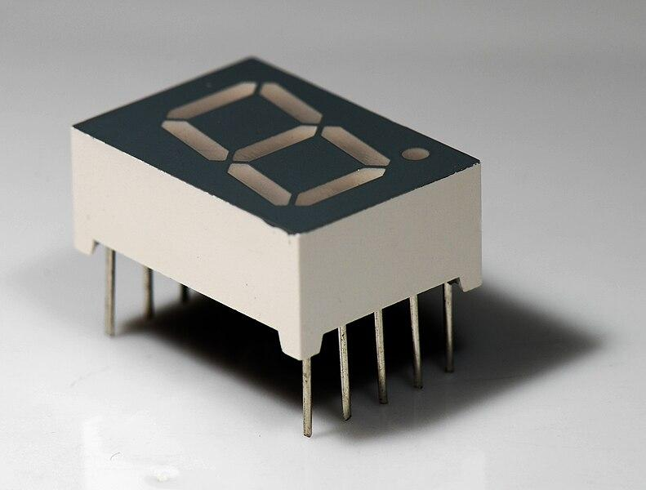

1. Breadboard

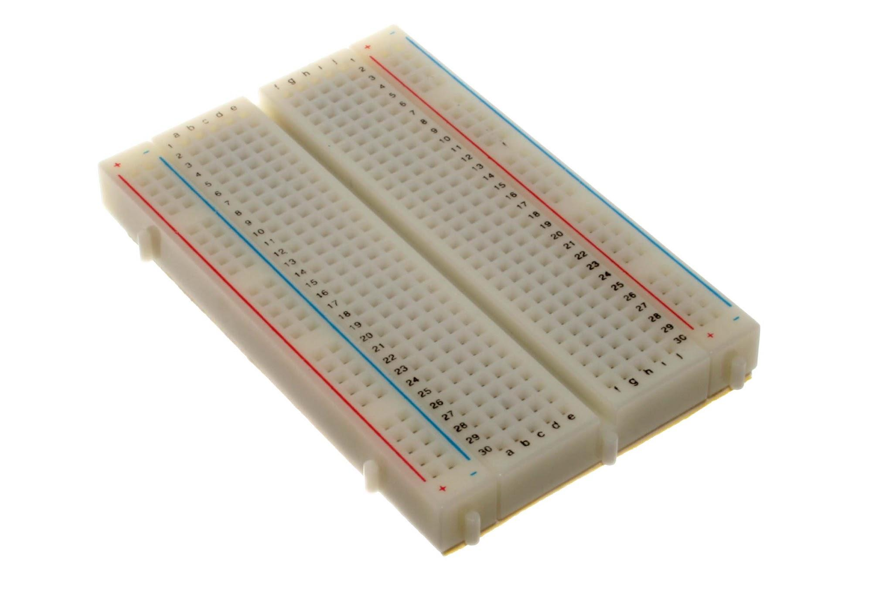

1. Arduino Board

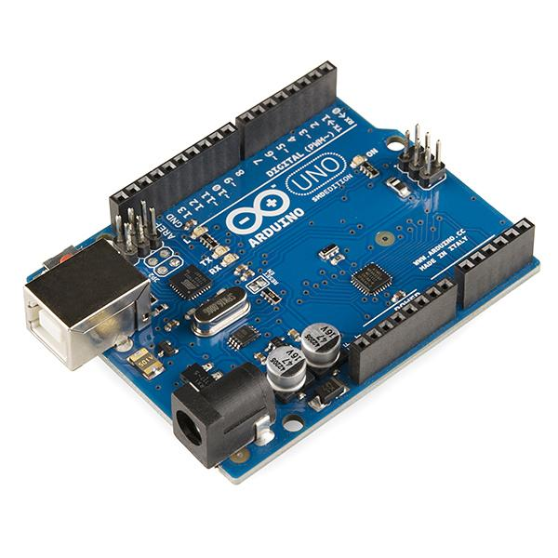

1. Push Button

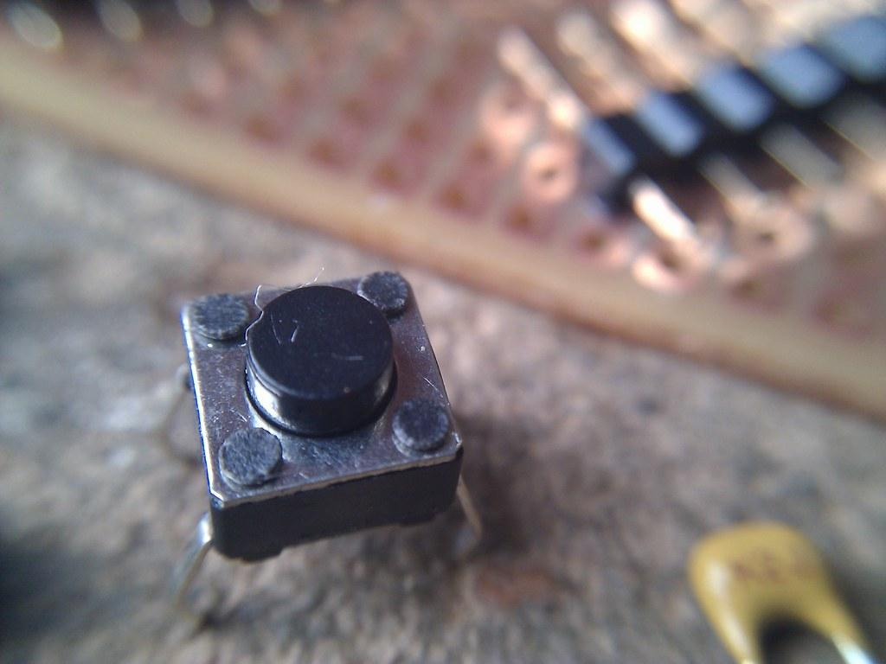

1. Wire

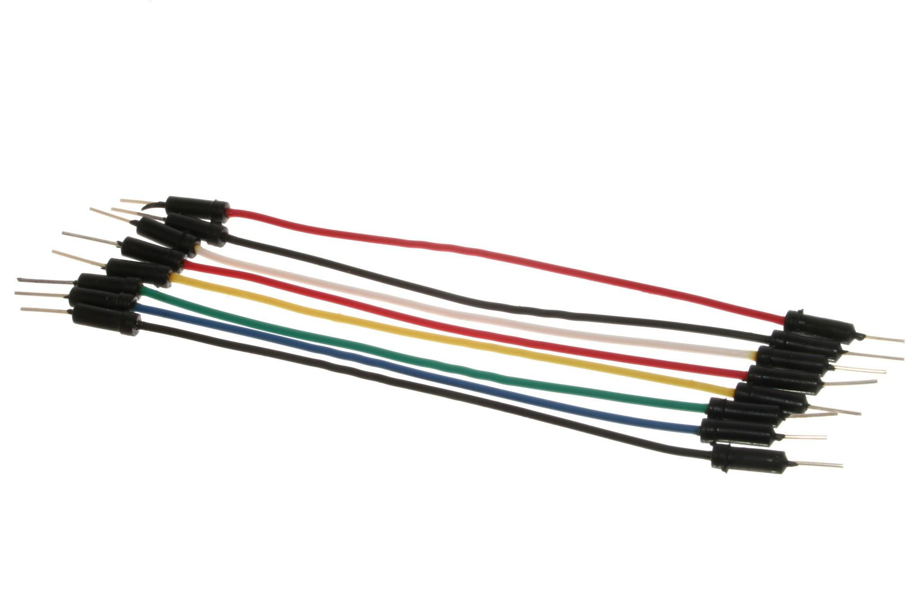

# Experimental Setup and Methodology

Firstly, the materials and components are placed onto the breadboard, and the common cathode 7-segment display is placed on the breadboard. Then the wire is connected to all of the legs of the display. One of the wires is connected to the ground on an Arduino UNO board. The remaining leg is connected to the digital pins on the Arduino board.

Next, the push button is placed on the breadboard and the wire is connected to the digital pin and the other to the common ground.

Lastly, the programming coding was made on the Arduino IDE on the computer. The Arduino board is connected to the computer via a USB cable to upload the coding into the Arduino 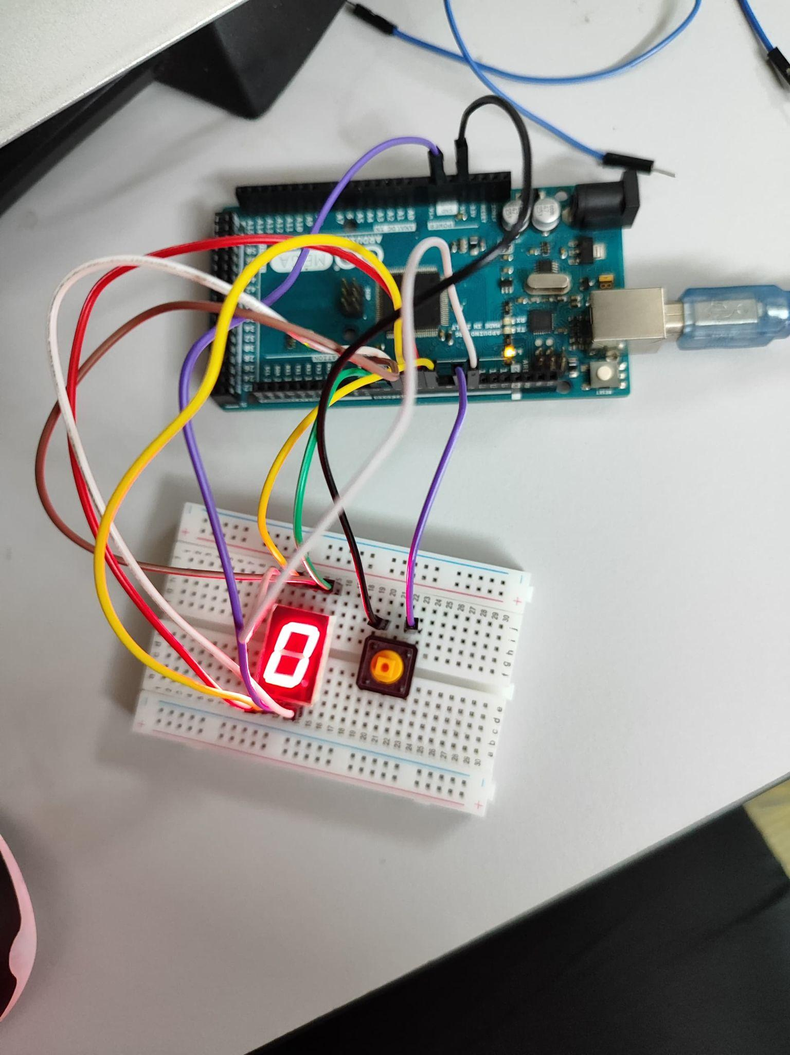board.

Figure 1: Full setup of the experiment.

# 

# Results

The 7-segment display correctly counted up in response to button presses, as demonstrated by the results of the experiment. This feature highlights the effective integration of the hardware configuration with the software. The experiment successfully implemented a mechanism for increasing the count using a single push button. The numerical digits, ranging from 0 to 9, were displayed sequentially on the 7-segment display. Once the count reached 9, it reset to 0 upon the next button press, allowing for continuous counting.

The system functioned reliably, registering each button press accurately, and ensuring no unintended skips or repetitions in the count. This demonstrates that such a system can be adapted for various applications that require counting or tracking, providing a simple yet effective solution for real-world uses.

# 

# Discussions

Hardware Discussion

1. **7-Segment Display**

A 7-segment display is assembled with seven LEDs, with some segment displays including an additional LED for a decimal point. Each LED has its leg to be inserted into a breadboard. Using microcontrollers, the LED can be controlled to display numbers and some alphabet letters that can be used to show hexadecimal numbers.

The 7-segment display can be configured into two types: common anode and common cathode. The common cathode can be achieved by connecting all cathode legs to the ground, thus lighting the LEDs requires the value of HIGH. On the other hand, the common anode is achieved by connecting all anode legs to Vcc and lighting the LEDs by giving the value LOW.

1. **Breadboard**

Breadboards are used to connect electronic components without the need of

soldering.

1. **Arduino board**

Arduino, which comes in many forms, is a microcontroller that can be integrated into many electronics projects by utilising its pin and be controlled by programming.

1. **Push button**

A push button is a mechanical device that acts as a switch. They can be used as a normally open(NO) or normally closed(NC) switch. Depending on the connections.

1. **Wire/ Jumper cable male-to-male**

Wires are used to connect electrical components.

Software Discussion

The attached Arduino code controls a 7-segment display to show numbers from 0 to 9, incrementing each time a button is pressed. It features a debounce mechanism to ensure accurate detection of button presses, preventing multiple increments from a single press. Some key functions of this code include:

1. **Pin Definitions**

The code begins by defining the pins connected to each segment of the 7-segment display and the button. Each segment (A to G) is assigned a specific digital pin on the Arduino, while the button pin uses an internal pull-up resistor for reliable input.

1. **Setup Function**

In the setup() function, all segment pins are configured as outputs, and the button pin is set as an input. The function initializes the display to show the starting number, 0, by calling the displayNumber() function.

1. **Loop Function**

The loop() function continuously checks the button's state. It detects a button press, waits for a debounce delay to filter out noise, and increments currentNumber if the button remains pressed. The display is updated accordingly, resetting to 0 after reaching 9.

1. **Debounce Function**

The debounce functionality is integrated within the loop to manage button presses. It uses a timestamp to ensure that only one button press is registered within a specified delay period, effectively filtering out any rapid, unintended toggles when the button is pressed.

1. **Display Function**

The displayNumber(int number) function controls which segments are lit based on the current number. It first turns off all segments, and then uses if-else statements to activate the appropriate segments for each digit from 0 to 9, ensuring the correct number is displayed.

ARDUINO CODE

/// Define the pins for each segment (D0 to D6)

const int segmentA = 2; // D0

const int segmentB = 3; // D1

const int segmentC = 4; // D2

const int segmentD = 5; // D3

const int segmentE = 6; // D4

const int segmentF = 7; // D5

const int segmentG = 10; // D6

const int buttonPin = 9; // Button pin

// Variable to hold the current number

int currentNumber = 0; // Start counting from 0

// Debounce variables

unsigned long lastDebounceTime = 0;

unsigned long debounceDelay = 50;

bool lastButtonState = HIGH;

void setup() {

// Initialize the digital pins as OUTPUTs

pinMode(segmentA, OUTPUT);

pinMode(segmentB, OUTPUT);

pinMode(segmentC, OUTPUT);

pinMode(segmentD, OUTPUT);

pinMode(segmentE, OUTPUT);

pinMode(segmentF, OUTPUT);

pinMode(segmentG, OUTPUT);

// Initialize button pin

pinMode(buttonPin, INPUT_PULLUP); // Use internal pull-up resistor

// Display the initial number (0)

displayNumber(currentNumber); // Show zero initially

}

void loop() {

// Read the button state

int buttonState = digitalRead(buttonPin);

// Check for button press (with debounce)

if (buttonState == LOW && lastButtonState == HIGH) {

// Wait for debounce delay

delay(debounceDelay);

// Read the button state again

buttonState = digitalRead(buttonPin);

// Only increment if the button is still pressed

if (buttonState == LOW) {

// Button was pressed, increase the number

currentNumber++;

if (currentNumber > 9) currentNumber = 0; // Reset to 0 after 9

displayNumber(currentNumber); // Update display with new number

}

}

lastButtonState = buttonState; // Store the last button state

}

// Function to display the current number on the 7-segment display

void displayNumber(int number) {

// Clear all segments first

digitalWrite(segmentA, LOW);

digitalWrite(segmentB, LOW);

digitalWrite(segmentC, LOW);

digitalWrite(segmentD, LOW);

digitalWrite(segmentE, LOW);

digitalWrite(segmentF, LOW);

digitalWrite(segmentG, LOW);

// Set segments based on the number using if-else statements

if (number == 1) {

digitalWrite(segmentB, HIGH); // b

digitalWrite(segmentC, HIGH); // c

} else if (number == 2) {

digitalWrite(segmentA, HIGH); // a

digitalWrite(segmentB, HIGH); // b

digitalWrite(segmentD, HIGH); // d

digitalWrite(segmentE, HIGH); // e

digitalWrite(segmentG, HIGH); // g

} else if (number == 3) {

digitalWrite(segmentA, HIGH); // a

digitalWrite(segmentB, HIGH); // b

digitalWrite(segmentC, HIGH); // c

digitalWrite(segmentD, HIGH); // d

digitalWrite(segmentG, HIGH); // g

} else if (number == 4) {

digitalWrite(segmentB, HIGH); // b

digitalWrite(segmentC, HIGH); // c

digitalWrite(segmentF, HIGH); // f

digitalWrite(segmentG, HIGH); // g

} else if (number == 5) {

digitalWrite(segmentA, HIGH); // a

digitalWrite(segmentC, HIGH); // c

digitalWrite(segmentD, HIGH); // d

digitalWrite(segmentF, HIGH); // f

digitalWrite(segmentG, HIGH); // g

} else if (number == 6) {

digitalWrite(segmentA, HIGH); // a

digitalWrite(segmentB, HIGH); // b

digitalWrite(segmentC, HIGH); // c

digitalWrite(segmentD, HIGH); // d

digitalWrite(segmentE, HIGH); // e

digitalWrite(segmentF, HIGH); // f

digitalWrite(segmentG, HIGH); // g

} else if (number == 7) {

digitalWrite(segmentA, HIGH); // a

digitalWrite(segmentB, HIGH); // b

digitalWrite(segmentC, HIGH); // c

} else if (number == 8) {

digitalWrite(segmentA, HIGH); // a

digitalWrite(segmentB, HIGH); // b

digitalWrite(segmentC, HIGH); // c

digitalWrite(segmentD, HIGH); // d

digitalWrite(segmentE, HIGH); // e

digitalWrite(segmentF, HIGH); // f

digitalWrite(segmentG, HIGH); // g

} else if (number == 9) {

digitalWrite(segmentA, HIGH); // a

digitalWrite(segmentB, HIGH); // b

digitalWrite(segmentC, HIGH); // c

digitalWrite(segmentD, HIGH); // d

digitalWrite(segmentF, HIGH); // f

digitalWrite(segmentG, HIGH); // g

} else if (number == 0) {

digitalWrite(segmentA, HIGH); // a

digitalWrite(segmentB, HIGH); // b

digitalWrite(segmentC, HIGH); // c

digitalWrite(segmentD, HIGH); // d

digitalWrite(segmentE, HIGH); // e

digitalWrite(segmentF, HIGH); // f

}

}

Electrical discussion

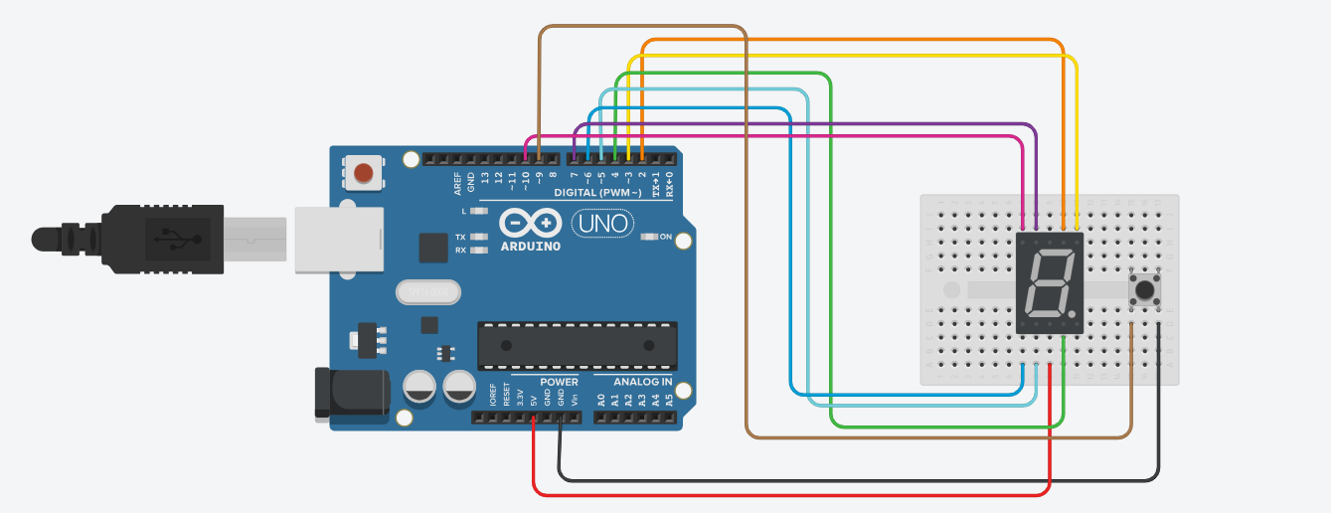

# 

# Question

1. How to interface an I2C LCD with Arduino? Explain the coding principle behind it compared with 7 segments display and matrix LED.

**Interfacing I2C LCD with Arduino**

The I2C LCD can be connected to the Arduino by connecting the VCC pin to 5V, the GND pin to the ground, the SDA pin and the SCL pin connected to the designated analogue pins. This setup allows for easy communication between the Arduino and the LCD.

**I2C LCD Coding Principles and Comparison 7 segment Display and matrix LED**

The I2C LCD uses libraries like LiquidCrystal_I2C to simplify communication. This abstraction allows users to send commands easily without needing to manage the low-level I2C protocol. The LCD is initialised with its I2C address and dimensions using functions like lcd.begin() and lcd.backlight(). For displaying text, functions like lcd.setCursor(column, row) and lcd.print("text") are employed, making it straightforward to output messages. This ease of use is one of the key advantages of I2C LCDs for textual displays.

However, 7-segment displays are controlled by individual pins for each segment (A-G). Users must specify which segments to light up for each digit, leading to more complex logic. Coding often involves if-else statements or arrays to determine segment activation.

Moreover, Matrix LEDs consist of an array of LEDs that can be individually controlled. Users manage which rows and columns are activated, allowing for complex patterns and graphics. This requires advanced logic, often involving bit manipulation or character maps. Coding for matrix LEDs can be intricate, and while libraries like Adafruit_GFX can simplify some aspects, a solid understanding of the grid layout is necessary. They excel at displaying dynamic content, such as animations and scrolling text.

In conclusion, I2C LCDs offer the simplest interface for text display, while 7-segment displays require more intricate segment control. Matrix LEDs are the most complex due to their grid structure. When it comes to display capabilities, I2C LCDs are ideal for text, 7-segment displays for numbers, and matrix LEDs for graphics and animations. Each display type has unique strengths and coding challenges, with I2C LCDs standing out for their simplicity and effectiveness.

# Recommendation

For the recommendation, we suggest adding a second push button to decrease the count. This would allow users to both increment and decrease the number displayed, making the system more versatile and improving the functionality of user input. Next, we recommend expanding the project by incorporating a multi-digit 7-segment display. By using multiple displays, you can show larger numbers or more complex outputs, such as a four-digit system to create a basic counter or clock. Lastly, consider introducing an external debounce component like a capacitor to improve input reliability. This would ensure that button presses are registered more consistently, reducing the chances of missed or unintended counts.

# Conclusion

To conclude, this project shows how to control a 7-segment display using an Arduino and a push-button switch. We faced many challenges and setbacks during the development, even though the procedures seemed simple. By carefully going through the code line by line and trying different solutions, we were able to fix the problems and make the system work.

This experience taught us the importance of being persistent and paying attention to detail in programming. We also learned that understanding how the 7-segment display works and how its connection in the circuit responded with the code, was essential for writing the functional code.

Overall, this project gives a solid foundation in digital control systems and opens the door for future improvements and more complex projects.

# Student Declaration

This is to certify that we are responsible for the work submitted in this report,that the original work is our own except as specified in the references and acknowledgement, and that the original work contained herein have not been taken or done by unspecified sources or person.We hereby certify that this report has not been done by only one individual and all of us have contributed to the report. The length of contribution to the reports by each individual is noted within this certificate.

We also hereby certify that we have read and understand the content of the total report and no further improvement on the reports is needed from any of the individual's contributors to the report.We therefore, agreed unanimously that this report shall be submitted for marking and this final printed report have been verified by us.

| NAME: Muhammad Basil bin Abdul Hakim | READ | ✔ |
| --- | --- | --- |
| MATRIC NO: 2215315 | UNDERSTAND | ✔ |
| SIGNATURE: | AGREE | ✔ |

| NAME: Muhammad Syafiq Bin Nor Azman | READ | ✔ |
| --- | --- | --- |
| MATRIC NO: 2213187 | UNDERSTAND | ✔ |
| SIGNATURE | AGREE | ✔ |

| NAME:Muhammad Hafiz Hamzah Bin Fansuri | READ | ✔ |
| --- | --- | --- |
| MATRIC NO:2212803 | UNDERSTAND | ✔ |
| SIGNATURE : | AGREE | ✔ |

| NAME: Muhammad Ammar Zuhair Bon Nor Azman Shah | READ | ✔ |
| --- | --- | --- |
| MATRIC NO: 2110259 | UNDERSTAND | ✔ |
| SIGNATURE: | AGREE | ✔ |

| NAME: MUHAMMAD RAZIQ BIN KAHARUDDIN | READ | ✔ |
| --- | --- | --- |
| MATRIC NO: 2120225 | UNDERSTAND | ✔ |
| SIGNATURE | AGREE | ✔ |